**Basic Information:** MachineGames developed *Wolfenstein: The New Order*. Bethesda Softworks published it. The game was released in 2014. According to the ESRB, Entertainment Software Rating Board, it is rated M for mature. Although this game is available on several platforms, I played this first-person shooter on my desktop computer.

**Gameplay and Controls:** The main game must be completed in single-player mode. Enigma codes are optional collections. These can be utilized to solve extra puzzles. Consequently, solved puzzles will unlock bonus modes.

Many challenges are spread throughout the game. However, there are few recurring ones. Primarily, the player must kill various enemies. These include hostile soldiers, animals, and mechanical creatures. Other challenges include obtaining special items, running towards and/or escaping from dangerous locations.

During the first chapter, movements are seamlessly introduced through challenges. Players must frequently walk and run to navigate distant locations. They can also climb, break items, swim, and slide under obstacles. Obviously, the player must know how to attack. Knives, guns, and explosives are in the player’s arsenal. Numerous playstyles can be performed. These range from dual wielding knives to powerful explosives. Weapon wheel scrolling is smooth. Nevertheless, it can get confusing. Players have the option to surpass maximum health. Of course, this super-health rapidly decreases.

Sometimes, a top-right user interface displays player controls. This allows clear understanding of keyboard controls. At first, mouse controls are difficult to identify. Players may have to experiment with mouse controls. If players identify relationships between inputs and outputs, then controls are straightforward.

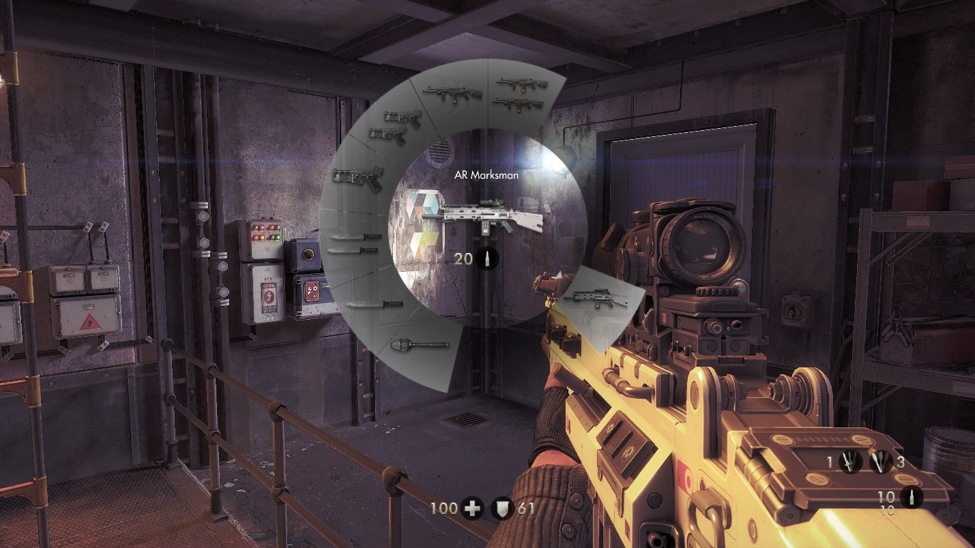

Photo above: Chapter three weapons I obtained on my second playthrough.

**Visuals:** Despite some fictional elements, the game is realistic and extremely detailed. However, close detail examination will likely ruin the experience. Obtainable items are indicated by subtle but frequent yellow highlights. Small yellow and blue icons help indicate destinations.

In-game UIs, user interfaces, are minimalistic and do not detract from the gameplay. Newly obtained weapons and possible actions are indicated at the top-right of the screen. Images, text, and icons complement the environment. Menu arrows, buttons, and sliders provide diverse customization options. Few menu sections elegantly display images with text. Menu and in-game UIs are well organized.

**Audio:** Intense situations blast adrenaline-pumping metal instruments. Ambience is reserved for calmer situations.

Environments, weapons, and objects sound realistic. Some fictional elements produce convincing audio. For instance, the Laserkraftwerk is a fictional weapon. However, it emits realistic energy sounds. Based on player settings, audio might be quiet or loud.

Characters have realistic voices that support immersion. Text supplements audio recordings.

**Characters:**Within a few minutes of gameplay, players know the main character’s name and role. The main character is William J. Blazkowicz, an American army ranger. His goal is to stop Nazis by helping the resistance.

In the first chapter, Blazkowicz encounters Wyatt and Fergus. One of these characters must be chosen to live. Neither choice has major influence on the story. Later in the story, Blazknowicz meets resistance members. Each person serves a different purpose. However, they share primary goals.

Enemies are organic, mechanical, and hybrid soldiers. The final encounters are Wilhelm Strasse and his sadistic creation.

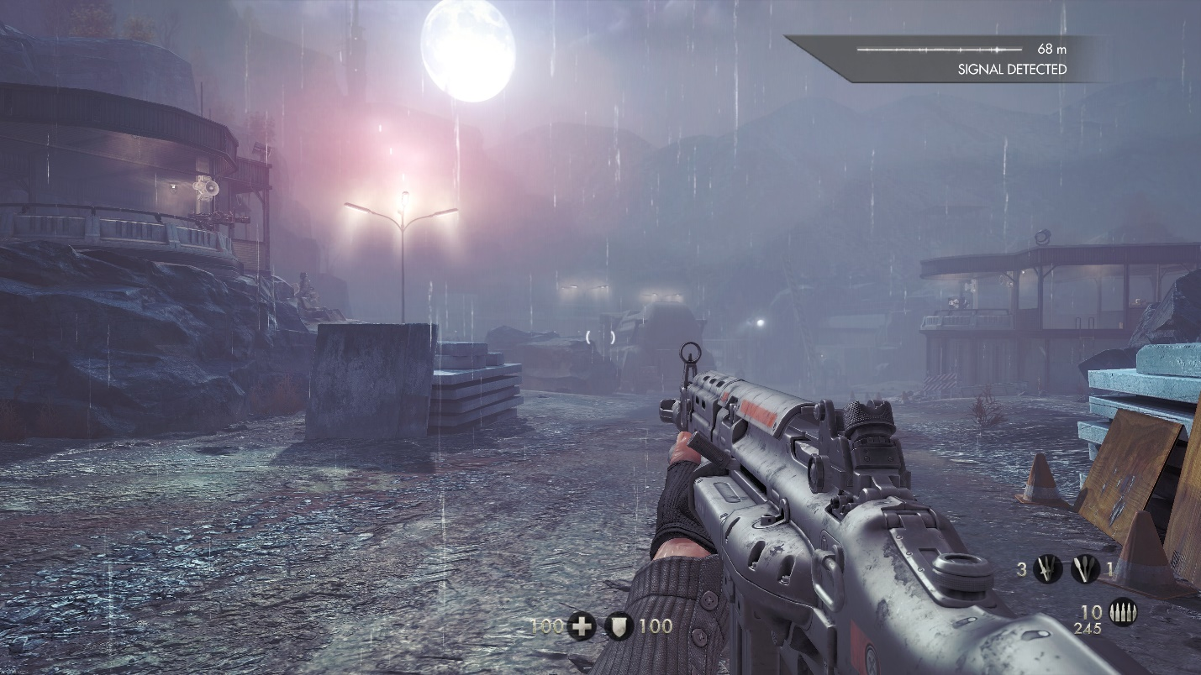

Photo above: Rough terrain, infrastructure and the glowing moonlight.

**Story and Progression:** In the first chapter, Blazkowicz is on a plane in 1946. Blazkowicz and his team encounter Wilhelm Strasse, known as General Deathshead. Near the first chapter’s end, Blazkowicz must choose between two soldiers, Wyatt and Fergus. Before the story can progress, one character must be chosen to die. In the 1960s, Blazkowicz regained consciousness inside an asylum. He escapes the area then later encounters the resistance. As a member, he infiltrates buildings to obtain items or information then escapes. Near the end, Blazkowicz must acquire nuclear codes on the Moon. Once he returns to Earth, he encounters Deathshead. Soon, Blazkowicz engages in combat with Strasse’s creation then Strasse himself. Deathshead is executed and Blazkowicz is fatally wounded.

**Final Thoughts:** I love the gameplay, audio, visuals, and story. The combination of intense and relaxed moments are well-presented. Nevertheless, I had a couple issues with the game. First, the mouse controls are not straightforward. Rather than numbers, mouse controls should be indicated by left, middle, and right. Destination indication symbols are too difficult to see. Icons should be slightly larger. Although the game is confusing at times, it is fun to play.

**Basic Information:**Mojang Studios is the developer and publisher of *Minecraft: Java Edition*. Although the initial release was in 2011, there have been frequent updates. ESRB rated the game E for everyone 10+ years old. Many devices support the game. However, I played this sandbox game on my desktop computer.

**Gameplay and Controls:** The game provides single-player and multiplayer game modes. Although not explicitly stated, the main game is recognized as single-player survival mode. With the exception of no respawns, hardcore mode is like survival. Creative mode allows players to freely explore and build. Multiplayer can be vanilla or have plugins. Vanilla *Minecraft* encompasses all non-modded versions. Plugins are modifications that players create themselves. These are meant to improve the player experience.

When players spawn into a single-player survival world, they encounter many challenges. Players can explore, craft, survive, and gather resources. All these activities serve to progress the game. However, players can go at their desired pace. Food is the only necessary survival resource. Weapons, armor, living quarters, potions, and tools are highly recommended. Although the main goal is optional, players tend to pursue it. Players must be in The End to complete the primary goal. The End is a fictional world that includes entities like endermen and the Ender Dragon. Before stepping into The End, players must obtain some eyes of ender. Ender pearls and blaze powders are required to craft this item. Slain endermen may drop ender pearls. Blaze powder must be acquired in the Nether. Once players are in the Nether, the game’s version of Hell, they must find mobs known as blazes. Players must kill blazes to acquire blaze rods. These items can be converted into blaze powder via a crafting table. First, eyes of ender are utilized to locate the end portal. When the portal is located, players must insert eyes of ender inside the portal slots. From here, the goal is to destroy end crystals and defeat the Ender Dragon. After the Ender Dragon is defeated, players can do whatever they desire.

Navigation is required to play the game. Players can walk, run, jump, and climb. Other possible actions include eating, crafting, using, breaking, placing, and dropping items.

Intuitive controls are walking, running, and jumping. Nevertheless, other aforementioned actions can be discovered through experimentation.

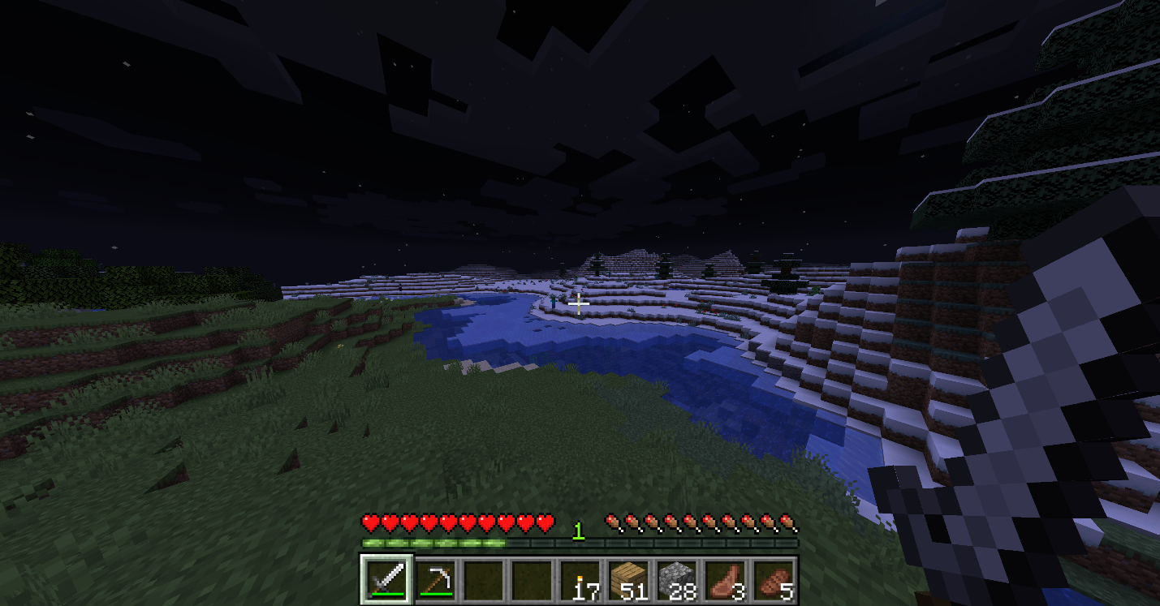

Photo above: My character looks at the dynamic scenery in survival mode.

**Visuals:** Most of the game consists of rustic, pixelated 16x16x16 cubes. Objects like water and flowers have transparency. All entity types have a consistent style.

Resource packs allow players to change the appearance of the game. Aesthetics can range from pastel to wasteland. Textures must be in the limits of default models.

All UI elements or intuitive or explained. Intuitive elements include single-player, multiplayer, options, and difficulty buttons. Underneath allow cheats and game mode options, clear descriptions are provided. Buttons and icons have a well-organized, pixelated style.

**Audio:** In the normal world, the game has a relaxing ambience. The Nether has spooky music. Otherworldly music is present in The End.

Different item types have different break and place sounds. However, an item’s break and place sounds are the same.

Mobs have diverse passive and hurt sounds. Players have various damage sounds based on the situation.

If players have jukeboxes, then they can play music discs. The music ranges from tranquil to unsettling.

**Characters:**Players determine their roles and playstyle. Custom skins, the character’s appearance, must be created on an external website.

Villagers are sometimes helpful mobs. Animals like pigs and cows are neutral.

Enemies are unoriginal or unique. Zombies and spiders are unoriginal. Meanwhile, creepers and ghasts are unique.

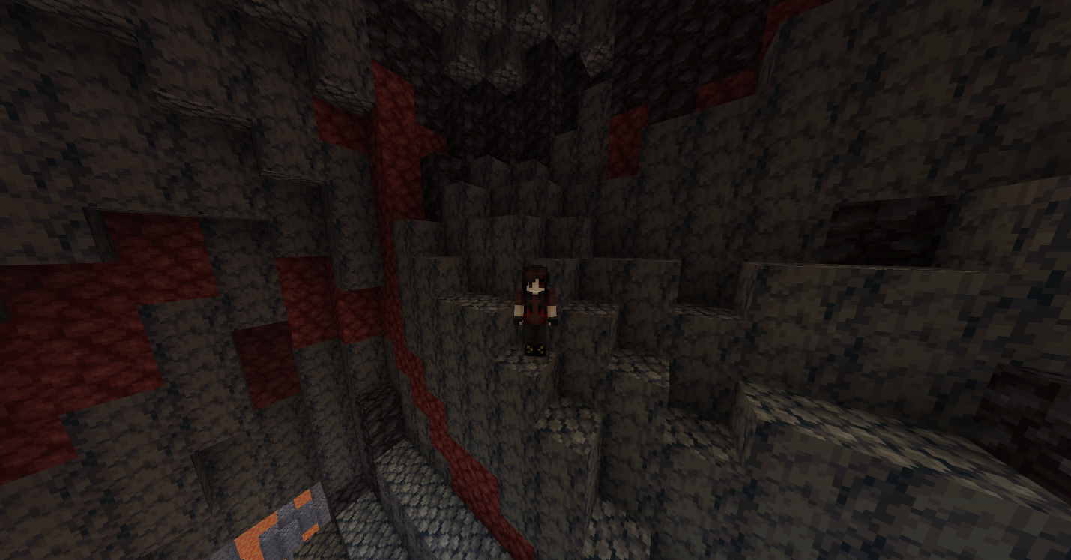

Photo above: My character’s skin (appearance) in the Nether.

**Story and Progression:** Players will spawn in one of various biomes. Some possible biomes include grassy plains, frigid mountains, and sunny deserts. First person mode is automatically set. Experimentation is necessary. Gameplay determines most of the player’s story. The story is mostly determined by pursuit of the main goal. If the goals are ignored, then they are free to do nearly anything.

**Final Thoughts:** Overall, *Minecraft*is relaxing and fun. However, the preparation stage can quickly get boring. It feels good to find diamonds. Creative mode is great for building competitions and roleplays. Plugin servers are more entertaining because of the possibilities.